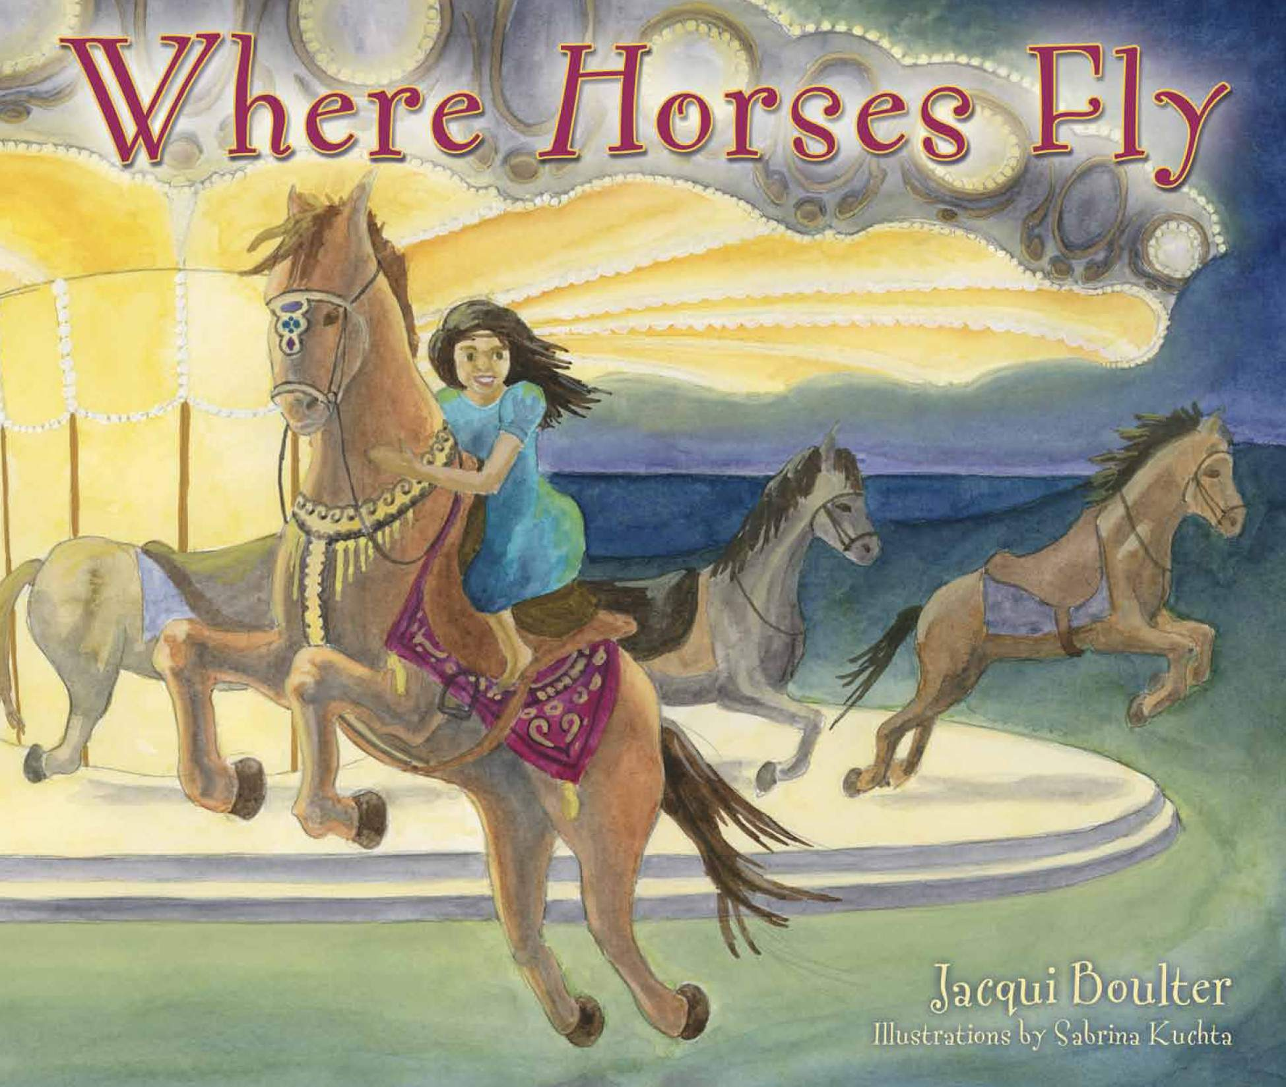
Jacqui Boulter, an author originally from Wellesley, MA, will be coming to your child’s class to read her book, Where Horses Fly, on Monday, June 10th, 2013.
While visiting her grandparents on Martha’s Vineyard, Caroline catches the brass ring on the Flying Horses Carousel. The magical ride that follows helps Caroline heal from the loss of her own beloved horse.
For more information contact: Sales@JacquiBoulter.com or visit www.WhereHorsesFly.com

Autographed hardcover copies of Where Horses Fly are $17.95.
(MA residents, please add 6.25% sales tax.)

Please have your child bring this completed form with your check to the classroom on or before Wednesday, June 5, 2013 if you would like an autographed copy waiting for them on June 10.

_ _ _ _ _ _ _ _ _ _ _ _ _ _ _ _ _ _ _ _ _ _ _ _ _ _ _ _ _ _ _ _ _ _ _ _ _ _ _ _ _ _ _ _ _ _ _ _ _ _ _

ORDER FORM Amount ___________
Please make checks payable to: Jacqueline L. Boulter, LLC MA 6.25% Tax ___________
Total ___________
Child’s Name _________________________________________

Number of copies________ Your email (optional) _____________________________________

Autograph to ___________________________________________________________________

